 **Hong Kong Institute of Vocational Education**

**ITP4506 Human Computer Interaction and GUI Programming**

**E-commerce Website**

|  |  |  |  |
| --- | --- | --- | --- |
| **Student ID** | **Name** | **Contribution** | **Signature** |
| 160450066 | LamKitYu | 50% |  |
| 160548082 | YauTsunSing | 50% |  |

Table of Contents

1. Background 1

2. User Analysis 2

2.1. Learning style 2

2.2. Tool preferences 2

2.3. Physical differences 2

2.4.Cultural differences 2

2.5. Knowledge of job 2

2.6. Application familiarity 2

2.7. Primary and secondary users 2

3. Web Concept 3

3.1. User Interface design 3

3.1.1. Home Page 3

3.1.2. Hotel page 4

3.1.3. Flight page 5

3.1.4. Register/Login Page 6

3.1.5. Shopping cart Page 7

3.1.6. Payment Page 8

# Background

The Happy Travel Ltd is a medium-sized travel agent. This company want to build a website for the tertiary student in Hong Kong. First, the website user interface should be user-friendly. Also, the website should be provide the search function for user searching the items. Moreover, it should be offer the

# User Analysis

## User characteristics

### Learning style

The website is target on the student so the user have a high learning skills to use the website. The users’ habits of learning are Read-then-do. The student will go to website first, they will see what is the information will show on the website. After they read the website, they can easy to use it. The user enter the website, they will see the photo 1. They enter this website because the want to search or buy the flight ticket or book the hotel. They can see the photo 1 will change to photo 2. Also, they can click the item on the top menu. It design can let the user easily to read the first page content.

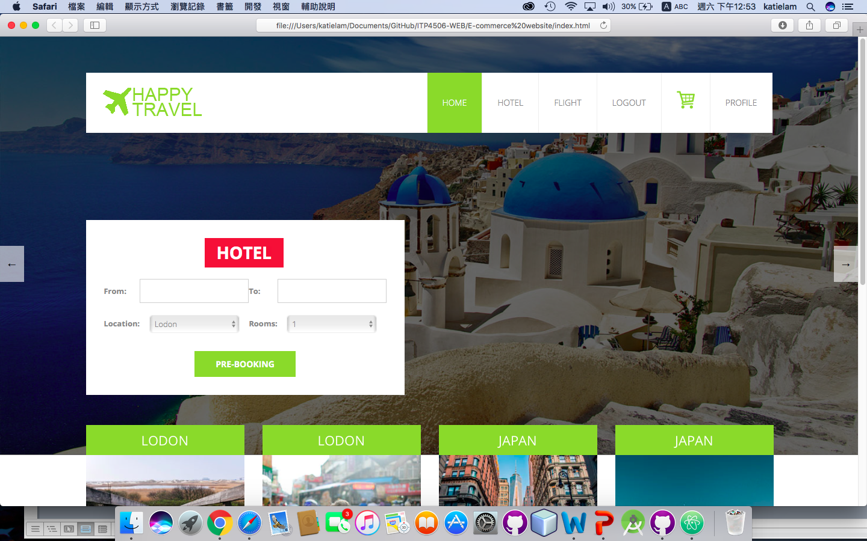(Photo 1)

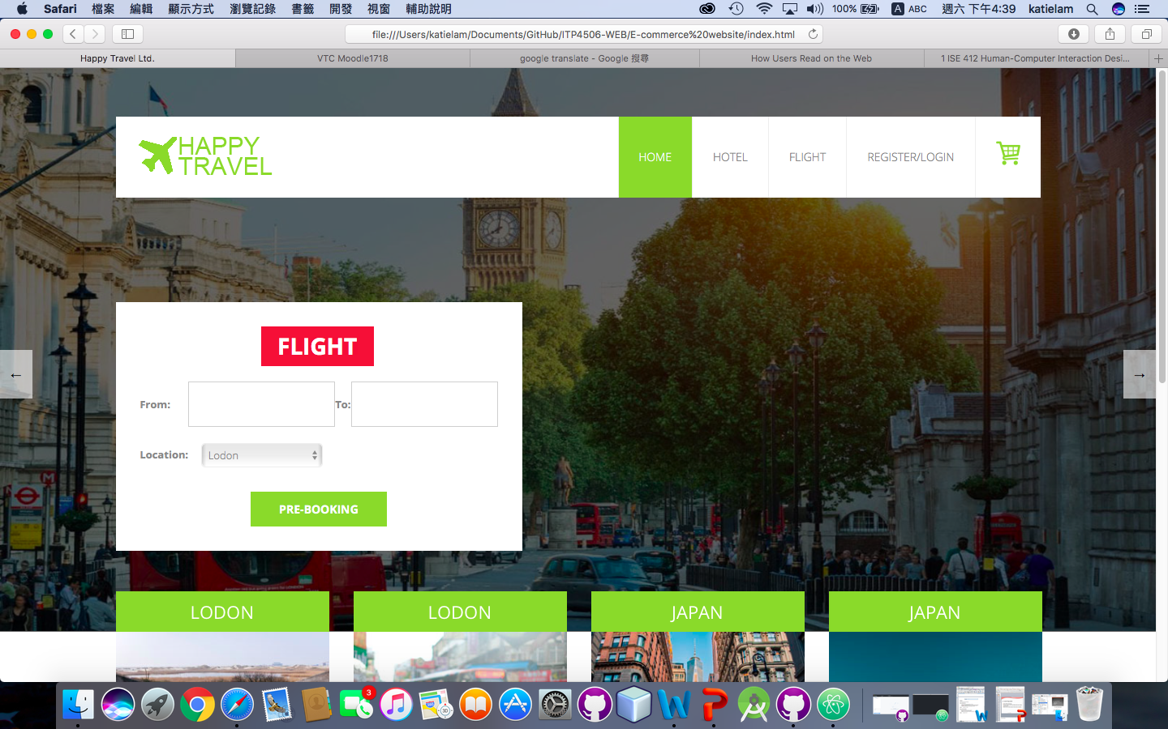(Photo 2)

### Tool preferences

The website will provide the search engines, menu and slide show.

For the search engines, the website is used the flexible box to include the search item. The user can select the date from the date picker, location, number of room and number of people are also is drop-down menu.

### 2.1.3. Physical differences

### 2.1.4.Cultural differences

### 2.1.5. Knowledge of job

### 2.1.6. Application familiarity

### 2.1.7. Primary and secondary users

# Web Concept

# User Interface design

|  |  |
| --- | --- |
| Design Principles | Description |
| Mental Model |  |
| Affordance |  |
| Content Organization |  |
| Visual Organization |  |
| Navigation |  |

## 3.1.1. Home Page



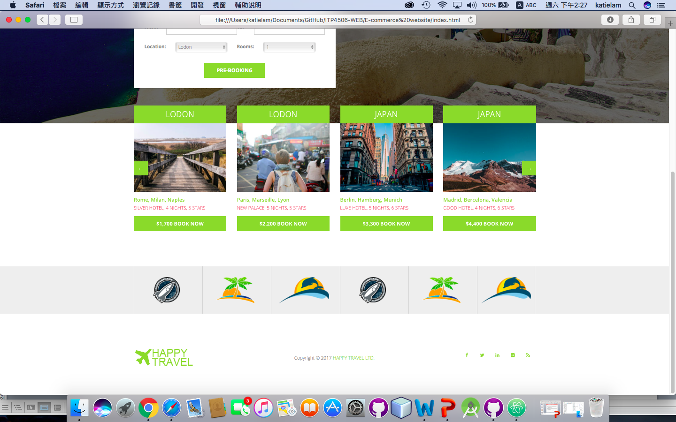

## 3.1.2. Hotel page

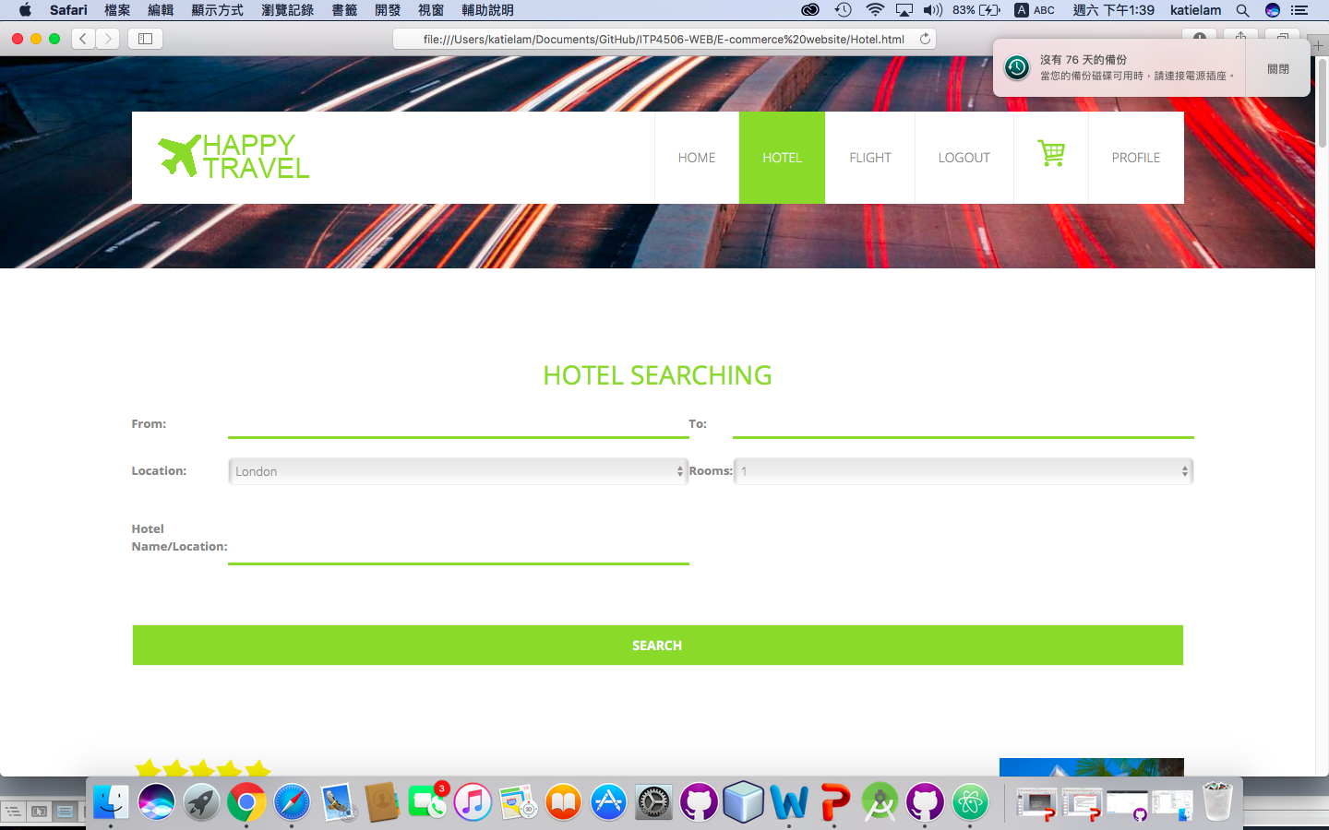

|  |  |
| --- | --- |
| Design Principles | Description |
| Mental Model |  |
| Affordance |  |
| Content Organization |  |
| Visual Organization |  |
| Navigation |  |

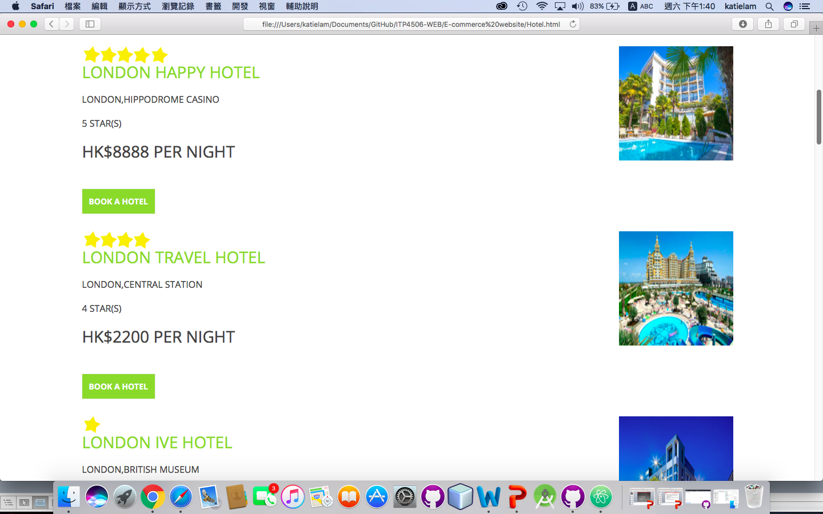

## 3.1.3. Flight page

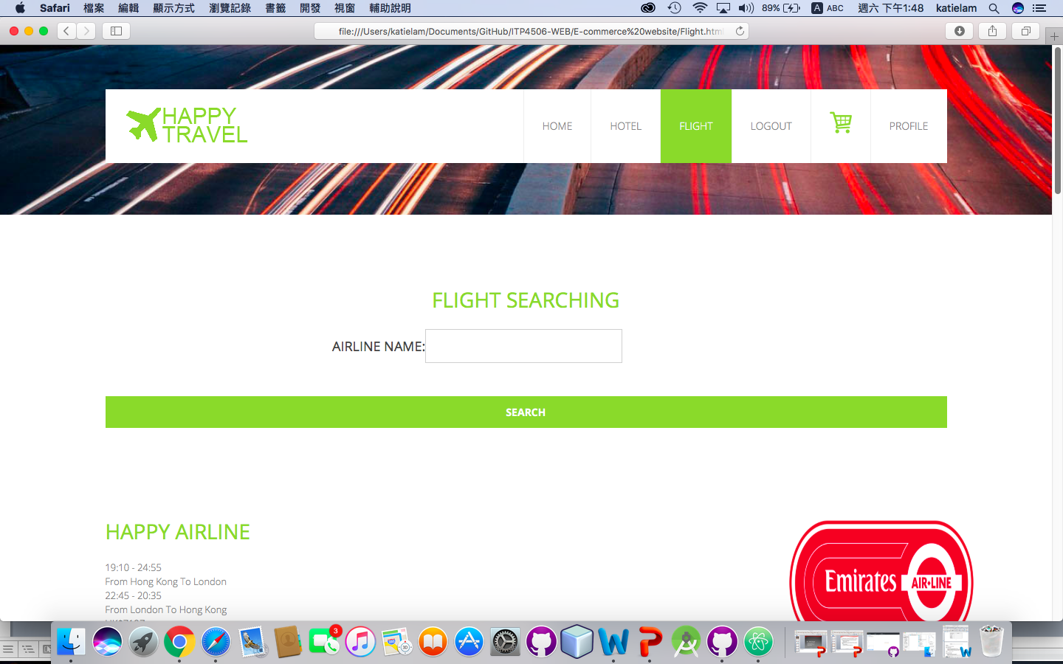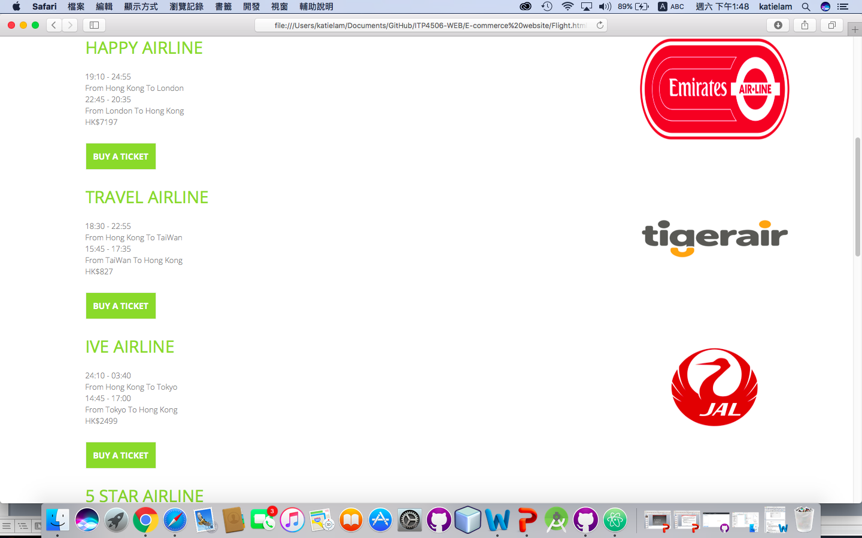

|  |  |
| --- | --- |
| Design Principles | Description |
| Mental Model |  |
| Affordance |  |
| Content Organization |  |
| Visual Organization |  |
| Navigation |  |

## 3.1.4. Register/Login Page

|  |  |
| --- | --- |
| Design Principles | Description |
| Mental Model |  |
| Affordance |  |
| Content Organization |  |
| Visual Organization |  |
| Navigation |  |

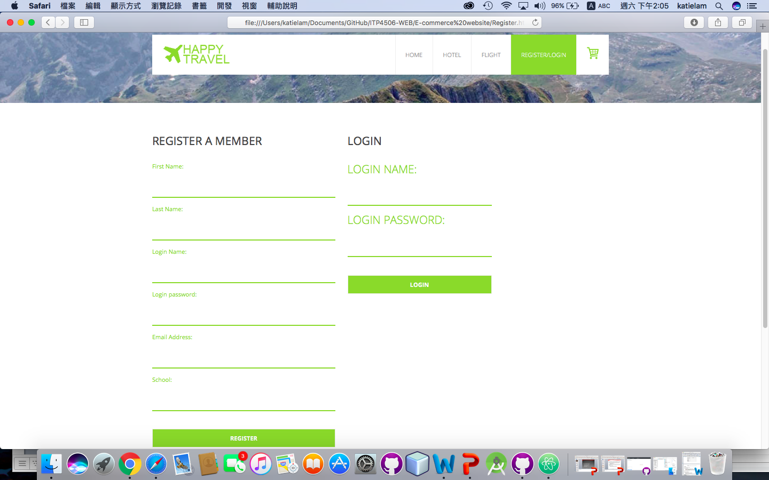

## 3.1.5. Shopping cart Page

## 3.1.6. Payment Page

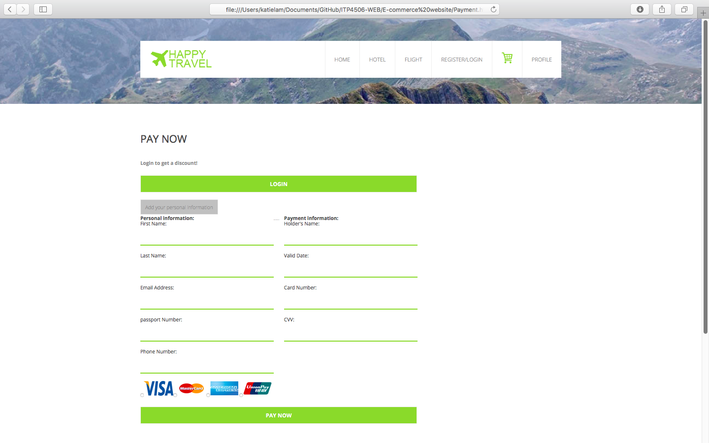

|  |  |
| --- | --- |
| Design Principles | Description |
| Mental Model |  |
| Affordance |  |
| Content Organization |  |
| Visual Organization |  |
| Navigation |  |